Task 17 Jenkins

Jenkins installed, configured and created users

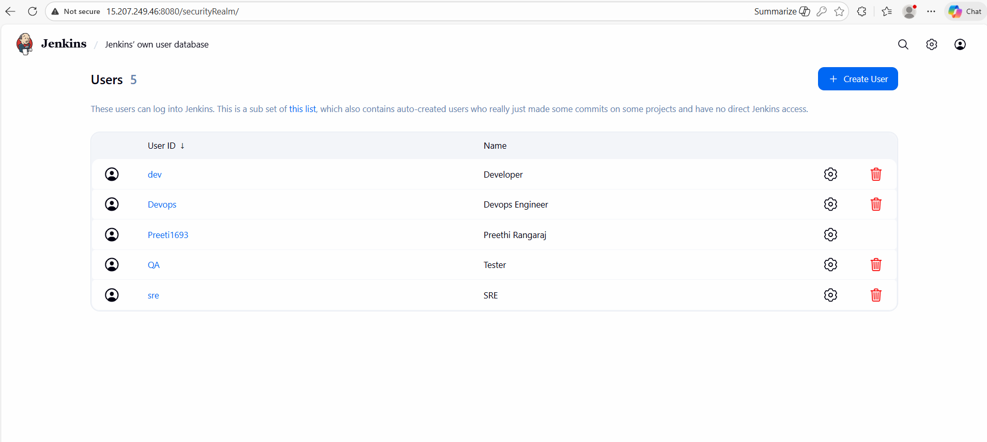

Jenkins CI/CD done
